Name: Due Date:
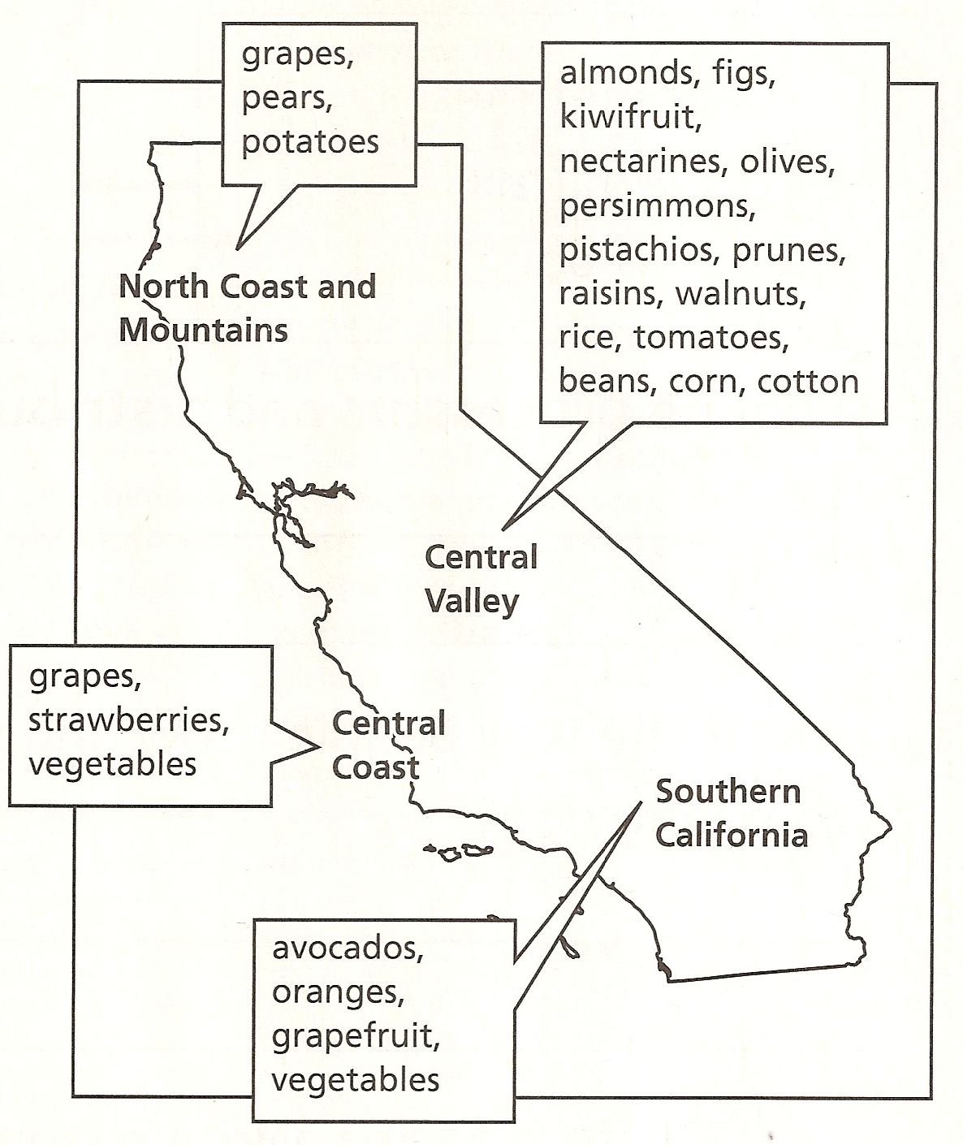
How Do People Grow and Use Food?

Task: Use the map to answer each question
in complete sentences.

1. What crops are grown in the Central Coast?
_____________________________________________
_____________________________________________
_____________________________________________

2. What crops are grown in Southern California?
_____________________________________________
_____________________________________________
_____________________________________________
3. What crops are grown in the Central Valley?
______________________________________________________________________________________________________________________________________________________________________________________
___________________________________________________________________________________________4. What are some crops are grown in the North Coast and Mountains of California?
______________________________________________________________________________________________________________________________________________________________________________________
___________________________________________________________________________________________5. Why do you think there are few crops grown in mountainous regions?
_________________________________________________________________________________________________________________________________________________________________________________________________________________________________________________________________________________

